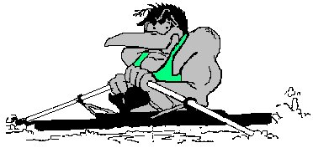
Glenorchy Rowing Club
Safety Rules and Guidelines
These rules and guidelines should be read in conjunction with the On Water Safety Guidelines and the On Water Code of Conduct produced by Rowing Australia and the Rowing Tasmania/MAST Making Rowing Safer guidelines (all available on the GRC website www.glenorchyrowing.com ).
Safety is your responsibility.
Rowing is a water-based activity and has inherent risks. By participating in rowing under the auspices of the Glenorchy Rowing Club and/or using the club’s equipment participants are doing so at their own risk.

General
- All rowers must be able to swim 50 metres wearing rowing clothing or wear an approved flotation device. Any rower who wears a flotation device for medical reasons is not to go on the water without a coach boat present.
- All rowers must understand the capsize drill and preferably have practiced it.
- All rowers must know and obey official and club local traffic rules in Elwick Bay and the Derwent River.

Safety around the boatshed
Boat storage: All sculls are to be stored on racks and oars on the oar racks.
Shed maintenance/cleaning: In order to reduce the chance of damage to equipment or injury to persons, the boatshed needs to be kept clean and aisles clear for easy access.
Use of gym equipment: All gym equipment is to be used in accordance with the manufacturer’s instructions. Ergos are to be wiped down after every use. Free weights are only to be used under supervision of another person.

Preparing to row
The club has a 4-oar policy. There must be a minimum of 2 persons rowing together at any one time (e.g. 2 single scullers or one double scull) unless there is a coach boat present. It is recommended that where possible a coach boat should accompany all crews. Novices must only row with a coach present.
Check water and weather conditions: Rowers and coaches should check the weather before they go out. Do not go out if conditions are not safe to row – i.e. high winds or rough water (white caps). If in doubt stay ashore. Under no circumstances are any boats to be launched in fog or thunderstorms.
Clothing: During daylight hours, the club prefers that all rowers wear a fluoro top to ensure visibility. Take additional clothing according to the weather (hats, neck warmers, gloves etc). In cold weather, wear appropriate clothing in layers. If rowing in the dark wear light coloured clothing. Take a water bottle.
Handling the boat: Take care when retrieving or placing rowing shells on racks as riggers from other boats or the racks themselves can easily damage the hull. If you cannot lift a boat or safely carry it, ask for assistance. There should be one person for every seat when carrying the boat (e.g. a quad should be carried by 4 people).
Launching and retrieving boats: Take care when launching and retrieving boats from the pontoon or beach. Pay particular attention to a potentially slippery surface caused by mud, seaweed, ducks or ice in the winter. Do not launch a boat if the MONA ferry has passed and the wash has yet to arrive.
Check your equipment: Ensure the boat has a bow ball and bailer, that heel safety straps fitted, all hatch covers are closed and all moving parts are tight and in good working order.
Lights: If rowing before dawn or after dark all sculls must have lights fitted at the bow and stern as per MAST requirements:
- All lights must be visible for a distance of 1 nautical mile from any direction.
- Bow light: a strobe light with 360° visibility.
- Stern light: a white light which will be visible at 270° from the stern. This light can be masked so that it does not interfere with the rower’s vision, provide the bow light is visible at 270° aft of the stern.
Red ‘bike lights’ are not to be used under any circumstances.
Coaching boats must have navigation lights fitted according to MAST requirements.
Coach boats: Ensure the coach boats have an anchor, oars, bailer, fire extinguisher and navigation lights as per MAST requirements. Coach boats should also have spare lifejackets, first aid kit, fuel, tow rope, powerful torch and thermal blankets. A mobile phone is a good idea. All people in a coach boat must wear a lifejacket at all times.
Sign out: All crews must sign the out/in log book, detailing name, scull, planned direction, departure time and estimated time of return.
Leaving for a row: Shut the external clubroom door and the roller door. Make sure you take a key with you when going out in a boat if needed or be aware of the clubroom key box location and combination code.

After rowing
Sign in.
Cleaning: Clean the boats and oars immediately after use with soapy water and then rinse using the hose. Pay particular attention to moving parts including gate, slides, wheels on seats foot stretchers tracks and fasteners. Oars are to be washed and rinsed, paying particular attention to the handles, buttons and sleeves. Put away the hose. Ensure hose is turned off and pressure released.
Damage: Report any damage to the clubhouse or club equipment to the Club Captain as soon as possible and write it up in the damage log book. This is to avoid further damage or injuries to any member who subsequently uses the boat and so that repairs can be organised.
Leaving: If last to leave:
- Check the in/out book to ensure all boats have returned. Start a search if it seems a boat has not returned in a reasonable time. Ring 000 if there is an emergency.
- Make sure all trestles are inside the shed (if there are some out there may be someone still on the water).
- Turn off all taps, lights and heaters, close the blinds and turn off the electrical appliances other than the fridge.
- Lock all doors, including connecting door between boat shed and clubroom.

First aid/safety equipment
The first aid kit is located in the kitchen (the door marked with ‘First Aid’ sign). Fire extinguishers are located at each end of the clubroom. Each safety boat also has a first aid kit. There is also a defibrillator near the front door.

Local hazards
When on the water, remember to keep a lookout for other boats of all kinds, and hazards.

Shorelines
Do not go too close to any shoreline, especially at low tide; there may be rocks or shallow water.

Wash
Wash can be dangerous for rowing boats. Both the MONA ferry and tug boats have a large wash. Do NOT approach the pontoon from the water or attempt to launch if the MONA ferry is in the vicinity and a wash is expected. It can take some time for the MONA ferry wash to arrive. If you are on the water in a big wash turn the boat parallel to the wash and sit at the easy oar position.
Tugboats can be a hazard south of Prince of Wales Bay.

Specific area warnings
Elwick Bay
- Underwater concrete piles at the shore end of the pontoon are a hazard at low tide.
- Stay clear of the point off Montrose Bay High School, as it is shallow.
- The area near the highway under the DEC is also shallow.
- Be aware of the ‘black pole’ in the middle of the bay and stay clear.

Moorilla Point
- Keep clear of the MONA ferry jetty and the MONA ferry.
- Rocks off the ‘island’ – don’t go between the pole and the shore.

Windermere Bay
- There are often strong currents around the mouth of Windermere Bay near Cadbury.

Golf Club Point
- There are often strong currents around the golf club point.

Bowen Bridge
- Water conditions often change markedly on either side of the Bowen Bridge.
- Never turn just upstream of the bridge to ensure the current doesn’t push you into the pylons.

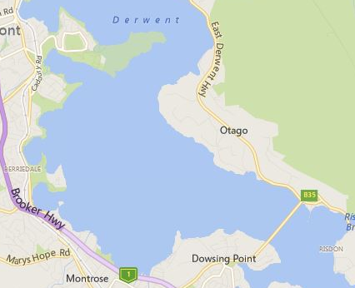

Rocks
Rocks
Projecting point
Shallow off point
Direction of travel
‘Black pole’
MONA ferry and jetty
Conditions change either side of Bowen Bridge
Approx course MONA ferry
Navigation lights
Shallow
Possible currents around point
Possible currents

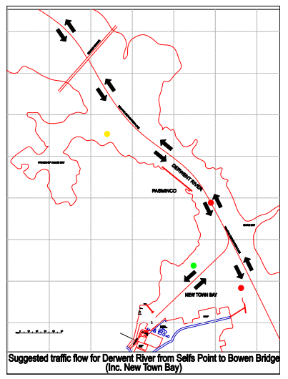
Local traffic conditions between the Bowen and Tasman bridges

Direction of traffic between the Bowen Bridge and the Tasman Bridge. When heading downriver keep to the western side of the river (Nyrstar side). When heading upriver keep to the eastern side of the river, close to the shore. If passing the Nyrstar wharf or Selfs Point be aware of any vessels approaching or preparing to leave. Be especially careful of tugboats, which have a large wash.
Note that rowing sculls are very difficult to see from the bridge of a ship, especially in low light conditions. Large vessels are not able to manoeuvre easily. Sculls should keep well clear of any large vessel.

South of Prince of Wales Bay
- Be aware of potential shipping movements and other sculls around Prince of Wales Bay, Risdon Wharf (Nyrstar) and Selfs Point. Keep a proper look out at all times.

New Town Bay
- There are several rowing clubs in New Town Bay; be especially careful in the area around the mouth of the bay for other sculls leaving or retuning to the bay. They may not necessarily obey the local traffic rules or keep a good look out.
- Stay outside of the green pole off New Town Bay; there is a rocky reef.

Swamping Drill

There need be no alarm in the case of your crew swamping.
Remember, your boat will not sink ........ DON’T PANIC

Once in the water a crew should never leave the boat until rescued by another craft or until reaching the shore.

Therefore it is worth repeating:

NEVER LEAVE THE BOAT

When a sinking appears certain, crews should steer towards the nearest shore.

If water finally swamps your boat, quietly ease yourself into the water alongside your rigger. Make sure all crew are accounted for, COUNT!

DON’T sit in the boat after swamping. This will make the boat sink in the water and may frighten non swimmers and also cause major damage to it.

Once in the water, hold onto your rigger, take orders from the stroke of your crew and by kicking your feet, propel your craft towards the nearest shore
.
Always listen to instructions from officials and respond immediately to their requests.

BUT remember there is NO NEED FOR PANIC and for your own safety NEVER LEAVE THE BOAT

(Issued by the Rowing Tasmania Inc as instruction to rowers for the protection of life and equipment in the event of any crew swamping.)
Cold water survival checklist

- Take all precautions to prevent immersion in the first place.
- Practice relevant techniques.
- Understand how cold water immersion affects physical and mental abilities.
- Don’t boat if ill, tired, affected by drugs or alcohol, hungry or thirsty.
- Dress appropriately, consider PFD.
- Consider the circumstances of each outing to ‘plan your own rescue’, and be prepared to adapt arrangements accordingly, or to cancel the outing if risk is too great.
- Avoid boating alone, or with no back up.
- If forced into the water try to control position of entry to avoid water getting into the nose or throat.
- During ‘cold shock’ concentrate on control of breathing and keeping mouth and nose out of the water.
- Hold onto something and try to get your body core out of the water as far as possible.
- Cover your head.
- Take time to think through best course of action in the circumstances.
- Keep your back to the waves.
- Keep as still as possible, avoid unnecessary manoeuvres.
- If wearing a PFD use HELP and huddle to conserve body heat.
- Only swim as a last resort– and try to use something as a float (such as an oar).
- When out of the water, victims affected by the cold should lie down, be wrapped up and kept still while awaiting transfer to hospital.

Capsize Drill

Rowing Tasmania’s video on the capsize drill can be seen here:
https://www.youtube.com/watch?v=yfmEpdP2KDo
In summary:
- Before you set out, always check
  - the heel restraints are secure and allow the heel to rise no more than 4 cm. This ensures your feet come out of the shoes.
  - the release cord across the velcro straps on the shoes is in place, and you know how to use it to release your feet.
  - your feet are not too tightly secured.
- When you capsize, your feet should come out immediately. However, if they don’t, remain calm and feel down your shins to the shoes and pull on the cord to release your feet.
- Once you are out of the boat, arrange both blades to run parallel with the hull to make the boat easier to right.
- By standing on one rigger you can get the leverage to reach to the far rigger and pull it up and over.
- Watch out for the far blade as the boat rights itself, as it can otherwise hit you on the head.
- Then either tow the boat back to land (go to the bow and swim on your back) or get back in.
- In a single scull, you should be able to get back into the boat, if you hold the handles of the blades together, by kicking and pulling yourself in. It can help to wrap a garment around the handles.
- If the water is cold, be aware that you are in danger. Even if you are normally a strong swimmer, cold water immersion shock and cold incapacitation will prevent you from swimming any distance effectively.
- To avert exposure, your priority is to get out of the water as soon as possible.
- STAY WITH THE BOAT. It is your buoyancy aid, and you can use it to get your body out of the water until help arrives.
- The only time you should consider leaving your capsized boat is if:
  - Staying with the boat will take you into greater danger.
  - The boat no longer remains an effective life raft.

Avoiding the risks of capsize.

Even experienced scullers can capsize. In general, avoid sculling in singles by yourself, particularly on days when the water is cold.

Never let go of the blades or pull the blades in to avoid obstacles.

