Glenorchy Rowing Club
Safety Rules and Guidelines
These rules and guidelines should be read in conjunction with the On Water Safety Guidelines and the On Water Code of Conduct produced by Rowing Australia and the Rowing Tasmania/MAST Making Rowing Safer guidelines (all available on the GRC website www.glenorchyrowing.com ).
Safety is your responsibility.
Rowing is a water-based activity and has inherent risks. By participating in rowing under the auspices of the Glenorchy Rowing Club and/or using the club’s equipment participants are doing so at their own risk.

General
- All rowers must be able to swim 50 metres wearing rowing clothing or wear an approved flotation device. Any rower who wears a flotation device for medical reasons is not to go on the water without a coach boat present.
- All rowers must understand the capsize drill and preferably have practiced it.
- All rowers must know and obey official and club local traffic rules in Elwick Bay and the Derwent River.

Safety around the boatshed
Boat storage: All sculls are to be stored on racks and oars on the oar rack.
Shed maintenance/cleaning: In order to reduce the chance of damage to equipment or injury to persons, the boatshed needs to be kept clean and aisles clear for easy access.
Use of gym equipment: All gym equipment is to be used in accordance with the manufacturer’s instructions. Ergos are to be wiped down after every use. Free weights are only to be used under supervision of another person.

Preparing to row
The club has a 4-oar policy. There must be a minimum of 2 persons rowing together at any one time (e.g. 2 single scullers or one double scull) unless there is a coach boat present. It is recommended that where possible a coach boat should accompany all crews. Novices must only row with a coach present.
Check water and weather conditions: Rowers and coaches should check the weather before they go out. Do not go out if conditions are not safe to row – i.e. high winds or rough water (white caps). If in doubt stay ashore. Under no circumstances are any boats to be launched in fog or thunderstorms.
Clothing: Wear suitable clothing and take additional clothing according to the weather (hats, neck warmers, gloves etc). In cold weather, wear appropriate clothing in layers. If rowing in the dark wear light coloured clothing. Take a water bottle.
Handling the boat: Take care when retrieving or placing rowing shells on racks as riggers from other boats or the racks themselves can easily damage the hull. If you cannot lift a boat or safely carry it, ask for assistance. There should be one person for every seat when carrying the boat (e.g. a quad should be carried by 4 people).
Launching and retrieving boats: Take care when launching and retrieving boats from the pontoon. Pay particular attention to a potentially slippery surface caused by ducks or ice in the winter. Do not launch a boat if the MONA ferry has passed and the wash has yet to arrive.
Check your equipment: Ensure the boat has a bow ball, that heel safety straps fitted, all hatch covers closed and all moving parts tight and in good working order.
Lights: If rowing before dawn or after dark all sculls must have lights fitted at the bow and stern as per MAST requirements:
- All lights must be all round lights (i.e. 360°), visible for a distance of 1 km from any direction.
- Bow light: port and starboard lights (red and green) are recommended, however a continuous white light or flashing white light (provided it flashes at least once per second) is acceptable.
- Stern light: a continuous white light or a flashing white light, provided it flashes at least once per second. This light can be masked so that it does not interfere with the rower’s vision, provided the bow light is visible from any direction.
- Red ‘bike lights’ are not to be used under any circumstances.
Coaching boats must have navigation lights fitted according to MAST requirements.
Coach boats: Ensure the coach boats have an anchor, oars, bailer, fire extinguisher and navigation lights as per MAST requirements. Coach boats should also have spare lifejackets, first aid kit, fuel, tow rope, powerful torch and thermal blankets. A mobile phone is a good idea. All people in a coach boat must wear a lifejacket at all times.
Sign out: All crews must sign the out/in board, detailing name, scull and estimated time of return.
Leaving for a row: Shut the external clubroom door and the roller door. Make sure you have a key with you when going out in a boat.

After rowing
Sign in.
Cleaning: Clean the boats and oars immediately after use with soapy water and then rinse using the hose. Pay particular attention to moving parts including gate, slides, wheels on seats foot stretchers tracks and fasteners. Oars are to be washed and rinsed, paying particular attention to the handles, buttons and sleeves. Put away the hose.
Damage: Report any damage to the clubhouse or club equipment to the Club Captain as soon as possible. This is to avoid further damage or injuries to any member who subsequently uses the boat and that repairs can be organised.
Leaving: If last to leave:
- Check the in/out board to ensure all boats have returned. Start a search if it seems a boat has not returned in a reasonable time.
- Ring 000 if there is an emergency.
- Make sure all trestles are inside the shed (if there are some out there may be someone still on the water).
- Lock all doors, including connecting door between boat shed and clubroom.
- Turn off all taps, lights and heaters.

First aid/safety equipment
The first aid kit is located in the kitchen (the door marked with ‘First Aid’ sign). Fire extinguishers are located at each end of the clubroom. A phone is located in the clubroom near the door to the toilets/boatshed.

Local hazards
Shorelines
Do not go too close to any shoreline; there may be rocks or shallow water.

Wash
Wash can be dangerous for rowing boats. Both the MONA ferry and tug boats have a large wash. DO NOT approach the pontoon from the water or attempt to launch if the MONA ferry is in the vicinity and a wash is expected. If you are on the water in a big wash turn the boat parallel to the wash and sit at the easy oar position.
Tugboats can be a hazard south of Prince of Wales Bay.

Specific area warnings
Elwick Bay
- Underwater concrete piles at the shore end of the pontoon are a hazard at low tide.
- Stay clear of the point off Montrose Bay High School, as it is shallow.
- The area near the highway under the DEC is also shallow.
- Be aware of the ‘black pole’ in the middle of the bay and stay clear.

Moorilla Point
- Keep clear of the MONA ferry jetty and the MONA ferry.

Windermere Bay
- There are often strong currents around the mouth of Windermere Bay near Cadbury.

Golf Club Point
- There are often strong currents around the golf club point near Austins Ferry.

Bowen Bridge
- Water conditions often change markedly on either side of the Bowen Bridge.
- Never turn just upstream of the bridge to ensure the current doesn’t push you into the pylons.

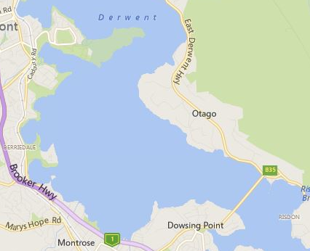

MONA ferry and jetty
Conditions change either side of Bowen Bridge
Approx course MONA ferry
Navigation lights
Direction of travel
Shallow
‘Black pole’
Possible currents around point
Shallow off point
Possible currents

Local traffic conditions between the Bowen and Tasman bridges
Direction of traffic between the Bowen Bridge and the Tasman Bridge. When heading downriver keep to the western side of the river (Nyrstar side). When heading upriver keep to the eastern side of the river, close to the shore. If passing the Nyrstar wharf or Selfs Point be aware of any vessels approaching or preparing to leave. Be especially careful of tugboats, which have a large wash.
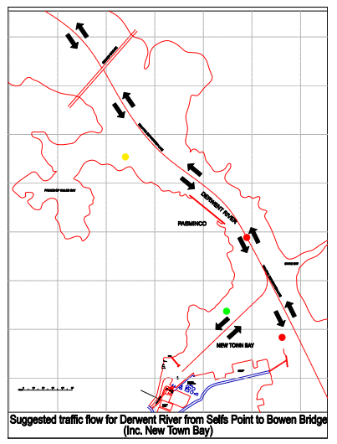
Note that rowing sculls are very difficult to see from the bridge of a ship, especially in low light conditions. Large vessels are not able to manoeuvre easily. Sculls should keep well clear of any large vessel.

South of Prince of Wales Bay
- Be aware of potential shipping movements and other sculls around Prince of Wales Bay, Risdon Wharf (Nyrstar) and Selfs Point. Keep a proper look out at all times.

New Town Bay
- There are several rowing clubs in New Town Bay; be especially careful in the area around the mouth of the bay for other sculls leaving or retuning to the bay. They may not necessarily obey the local traffic rules or keep a good look out.
- Stay outside of the green pole off New Town Bay; there is a rocky reef.

Swamping Drill

There need be no alarm in the case of your crew swamping.
Remember, your boat will not sink ........ DON’T PANIC

Once in the water a crew should never leave the boat until rescued by another craft or until reaching the shore.

Therefore it is worth repeating:

NEVER LEAVE THE BOAT

When a sinking appears certain, crews should steer towards the nearest shore.

If water finally swamps your boat, quietly ease yourself into the water alongside your rigger. Make sure all crew are accounted for, COUNT!

DON’T sit in the boat after swamping. This will make the boat sink in the water and may frighten non swimmers and also cause major damage to the skiff.

Once in the water, hold onto your rigger, take orders from the stroke of your crew and by kicking your feet, propel your craft towards the nearest shore
.
Always listen to instructions from officials and respond immediately to their requests.

BUT remember there is NO NEED FOR PANIC and for your own safety NEVER LEAVE THE BOAT

(Issued by the Rowing Tasmania Inc as instruction to rowers for the protection of life and equipment in the event of any crew swamping.)
Cold water survival checklist

- Take all precautions to prevent immersion in the first place.
- Practice relevant techniques.
- Understand how cold water immersion affects physical and mental abilities.
- Don’t boat if ill, tired, affected by drugs or alcohol, hungry or thirsty.
- Dress appropriately, consider PFD.
- Consider the circumstances of each outing to “plan your own rescue”, and be prepared to adapt arrangements accordingly, or to cancel the outing if risk is too great.
- Avoid boating alone, or with no back up.
- If forced into the water try to control position of entry to avoid water getting into the nose or throat.
- During “cold shock” concentrate on control of breathing and keeping mouth and nose out of the water.
- Hold onto something and try to get your body core out of the water as far as possible.
- Cover your head.
- Take time to think through best course of action in the circumstances.
- Keep your back to the waves.
- Keep as still as possible, avoid unnecessary manoeuvres.
- If wearing a PFD use HELP and huddle to conserve body heat.
- Only swim as a last resort– and try to use something as a float (such as an oar).
- When out of the water, victims affected by the cold should lie down, be wrapped up and kept still while awaiting transfer to hospital.

