Glenorchy Rowing Club Inc.
Fun, Fitness and Friendship
www.glenorchyrowing.com

Member Information

The Glenorchy Rowing Club welcomes active rowers, non-rowing members and friends. Our motto is 'Fun, fitness and friendship'.

Membership
We have several membership options to suit your interests.
Membership categories
Pennant Rower
Pennant rower membership includes:
- the use of all the club’s equipment and facilities
- unlimited on water sessions
- transport costs of sculls to and from regattas
- access to coaching if possible
- hire of club rooms at a discount rate, and
- eligibility for election to office & voting rights
Note: Rowers need to pay the Rowing Tasmania registration fee and their own race entry fees.

Pennant Rower (Student)
The competitive student rower must be a full-time student. Membership includes:
- the use of all the club’s equipment and facilities
- unlimited on water sessions
- transport costs of sculls to and from regattas
- access to coaching if possible
- hire of club rooms at a discount rate, and
- eligibility for election to office & voting rights.
Note: Rowers need to pay the Rowing Tasmania registration fee and their own race entry fees.

Non-Pennant Rower
Non pennant rowing membership includes:
- the use of all the club’s equipment and facilities
- access to coaching if possible
- permission to compete at local club regattas (i.e. New Norfolk, Sandy Bay, and Royal Hobart) & the State Masters regatta
- hire of club rooms at a discount rate, and
- eligibility for election to office & voting rights
Note: Rowers need to pay the Rowing Tasmania registration fee, their own race entry fees, and share of cost to transport boats to regattas.

Associate
This category is for non-rowing members & coaches. Membership includes:
- hire of club rooms at a discount rate
- use of the gym equipment, and
- eligibility for election to office & voting rights.

Visiting Rower
This category is for financial members from another club who are rowing from the Glenorchy clubrooms, for example as a composite member of a Glenorchy crew. Visiting Rower membership includes:
- the use of all the club’s equipment and facilities
- transport costs of sculls to and from regattas if rowing with a Glenorchy crew
- access to coaching if possible.

Visiting Rowers:
- must be registered with Rowing Tasmania
- will need to pay their own race entry fees
- are not eligible for election to office or have voting rights, and
- can’t hire the club rooms at a discount rate.

Casual Rower (non-competitive)
This category is for those rowers who just want to row occasionally. Casual members:
- must apply for Casual Rower membership
- must be registered with Rowing Tasmania
- will need to pay a fee per row
- are not eligible for election to office or have voting rights, and
- can’t hire the club rooms at a discount rate

Life Member
Life members have full rights and privileges of club membership. Membership includes:
- the use of all the club’s equipment and facilities
- unlimited on water sessions
- transport costs of sculls to and from regattas
- access to coaching if possible
- hire of club rooms at a discount rate
- eligibility for election to office & voting rights.
Note: Rowers need to pay the Rowing Tasmania registration fee, their own race entry fees, and share of cost to transport boats to regattas

Honorary Life Member
Honorary life members are elected by the members at the Annual General Meeting as a mark of the club’s appreciation of their service. They have the full rights and privileges of club members without payment of a subscription.

Friend
For family & friends of club members who volunteer to assist the club with activities. If involved with any on water activity (e.g. in safety boat) friends must be registered as a volunteer with Rowing Tasmania. Friends:
- are not eligible for election to office or have voting rights
- can’t hire the club rooms at a discount rate.

Affiliate Member
Affiliate Members:
- have access to the GRC boat shed & clubrooms
- can use gymnasium
- can hire club rooms at a discount rate, but
- are not eligible for election to office or have voting rights of the Glenorchy Rowing Club Inc.

Affiliate Member (Junior)
Membership of Glenorchy Rowing Club for Junior Affiliate members under 18 years of age. Affiliate Member (Junior) members:
- have access to the GRC boat shed & clubrooms
- can use the gymnasium, but
- are not eligible for election to office or have voting rights of the Glenorchy Rowing Club Inc.

Rowing Tasmania Registration
For insurance purposes, all members or coaches other than Affiliate Members who go on the water in any capacity must also be registered with Rowing Tasmania.

Member Responsibilities
Members are expected to:
- pay all membership fees when they become due
- contribute to tasks such as cleaning and maintaining the clubrooms and
- contribute to club activities including fundraising however they can.

Fees
The management committee set the membership fees each year. The club membership year commences on 1 September. Membership dues are payable in full on 1 October or by instalment in consultation with the Treasurer.

Membership fees do not include registration with Rowing Tasmania (RT). RT registration forms are available from committee members or from the GRC website.

Safety
All members must read and adhere to the club’s safety guidelines, which can be found at www.glenorchyrowing.com or obtained from any committee member. A copy can also be found on the club noticeboard in the boat bay.

Equipment
The Club Captain with the assistance of the Vice-Captain is responsible for ensuring the club's equipment is properly managed. The use of club equipment is at the discretion of the Club Captain.

Use of boats
The club has several sculls and associated equipment for use by members in accordance with their membership. Pennant members and those who are competing a have preferential use of club facilities and equipment.

No club boat can be taken out onto the water without a coach/club member in a rescue boat present unless the Club Captain has given prior permission. All rowers must enter details of their proposed row in the red folder, including departure time, expected time of return and proposed course.

Members must have a MAST motor boat licence to operate a rescue boat. Anyone in a rescue boat must wear PFDs in accordance with MAST regulations and all rescue boats must carry safety equipment as required by MAST.

No club boat is to be modified without the Club Captain’s permission.

No privately stored equipment can be used without the owner’s permission of the owner.

Equipment damage
Boats and equipment do get damaged. Any damage should be reported to the Club Captain as soon as possible after the incident occurs. Record the damage in the Damage and Repairs record book in the red folder.

Repairing equipment does take time and is expensive. To minimise damage to the equipment, the club encourages safe practices.

Gym Equipment
All members have access to the gym equipment.

Private boat storage
If room is available and the Club Captain approves, members can store privately owned boats and associated equipment such as oars in the boatshed. There is an annual fee,

Fundraising
Membership fees generally pay for the cost of running the club. Fundraising contributes to maintaining equipment and purchasing new equipment. The club's main fundraising activities are:
- hiring the clubroom
- staffing the kiosk at Lake Barrington
- Introduction to Rowing courses
- club social functions
- raffles, chocolate sales etc.

Club members should assist in at least two fundraising activities during the year.

Competition
Members competing at Rowing Tasmania regattas need to be registered with Rowing Tasmania.

Members who are competing should wear the Glenorchy Rowing Club colours (black, white and green) preferably in the club sooty (racing kit) unless they are members of another club rowing in a composite crew.

At the discretion of the committee the club may pay seat fees for rowers representing the club at National regattas. Any rower can apply to the committee for this to be considered.

Club rooms
The clubhouse is the club’s most asset. Members using the clubrooms should keep it clean and tidy, clean up any spills, etc, remove any items that belong to them and report any damage or breakage.

For security reasons the clubroom is divided into 2 areas. Only club members can use the boat bay.

Smoking is not permitted anywhere in the building.

Club room hire
The club room is available for hire, although club functions have priority over hire for other purposes. Hiring the clubroom is at the discretion of the committee, but in no circumstance is it available for hire for 18th or 21st birthday parties.

The hirer must enter into an agreement and pay a deposit. The deposit is refunded if in the opinion of the responsible club member the clubroom is left clean and tidy and there is no damage or breakage. Hirers of the club have access only to the main hall and the toilets, but not to the boat bay
Club members can hire the building at a discount rate although they will still need to pay the deposit.

Keys
Members who need to access to the clubroom at times when no other member is available can have a key. Some keys allow access to all areas of the club; others are restricted to certain parts of the building. There is a $25 deposit which is refunded when the key is returned.

Keys are not to be lent to any other person. If the key is lost the member should report it immediately to the Committee. Key holders must return keys if they are no longer a club member or are asked to do so by the Committee.

Key holders must make sure the building is locked when they leave unless there is another member with a key present.

A Potted History

Unlike other rowing clubs in and around Hobart, the Glenorchy Rowing Club has a relatively short history.

The inaugural meeting of the Club was held at nearby Rosetta High School, on the 14th of April 1971. A group of prominent businessmen and professionals from the area, many of them from the Glenorchy Football Club, formed a steering committee to oversee the formation of the new club. The Glenorchy Rowing Club was officially established in 1972.

Initially all equipment used by the Club was borrowed from other rowing clubs in the south. A sponsorship and fundraising program saw the acquisition of several crew boats, blades, a trailer and coach’s runabout.

The club initially operated from the old Montrose Bay Yacht Club building, which was vacant. The building was purchased from the yacht club for $325. The club operated from here until the building was demolished in 1977 to make way for the reclamation of the area for construction of the Brooker Highway.

For several seasons following the demolition the Club operated from trailers stored at various locations throughout the Northern Suburbs. The committee investigated several sites along the foreshore from Prince of Wales Bay to Austins Ferry to find slightly more sheltered waters and land suitable for new clubrooms and boat shed and selected Windermere Bay.

However, the lack of suitable facilities had reduced rower numbers and by 1980 the future of the club looked grim. Following consultation with the Glenorchy City Council and with funds sourced from the Commonwealth Employment Program, it was decided to rebuild the Club at Montrose Bay. The present Club building was built and officially opened in 1985.
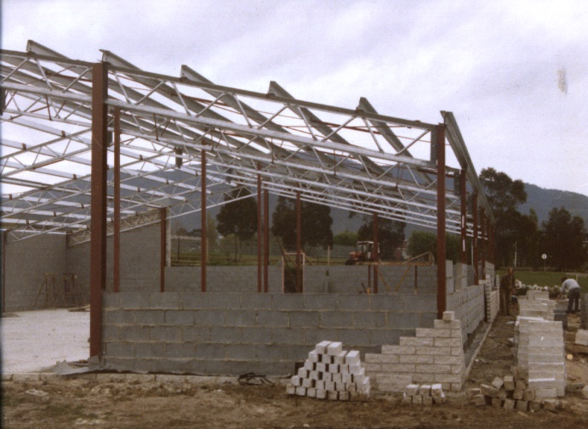
The present club rooms
under construction in 1985

The Glenorchy City Council has also been a valued supporter of the club for many years and currently owns the building, which the rowing club leases.

Crews from Rosetta High School, Claremont High School, New Town High School, Cosgrove High School, St Virgil’s College, Hobart Matriculation College, Dominic College and Guilford Young College have boated from the from the Glenorchy Rowing Club, although the club currently has no school rowers.

Although having had periods of very low membership, rowers in Glenorchy colours have won state and national titles and have been selected for both national and international competition. The Glenorchy Rowing Club has a history of producing champion rowers. Two previous members have rowed for Australia; Shaun Finlayson at the 2008 World Rowing Championships and Dana Felatic who participated in both World Championships and at the 2004 Athens Olympics where she won bronze in the women's quad scull.

The official club logo is the 'magpie'. The magpieis linked to the beginning of the club when it was associated with the Glenorchy Football Club.

